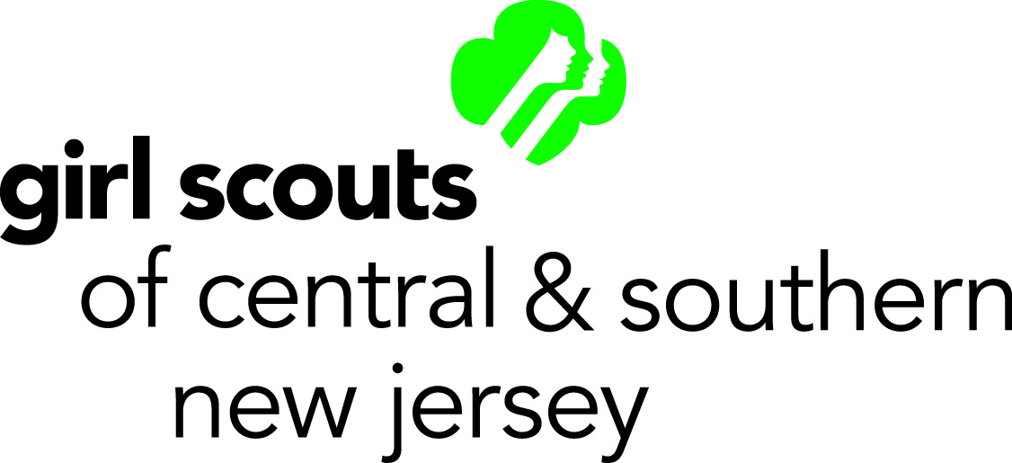
Gold & Silver Awards
Money-Earning Activity Form

To be filled out by Team or Girl:
Service Unit: Troop Number: Leader:

Email: Phone: Anticipated Profit: $

Date and location of activity:

Description of activity:

Check all of the following that apply to this money-earning activity:
☐ Group/girl has read Money-Earning Basics (MEB) found on www.gscsnj.org.
☐ Participation is voluntary.
☐ Planning has taken place with girls understanding their financial goals.
☐ Activity is suited to the age and abilities of the group.
☐ Money earned is for Girl Scout Gold or Silver Award project and is not to be retained by individuals.
☐ Activity does not involve any game of chance, including 50/50, raffles, or BINGO of any kind.
☐ Group/girl is not directly soliciting for cash or hosting a product demonstration party.
☐ Group/girl is not selling or endorsing commercial products.
☐ Group/girl is not soliciting business/money for another organization or company, including percentage evenings (use Incoming Business Donation form for adult-led business partnerships).

If the money earning activity information is included in the Award Proposal Form, then it is reviewed and approved along with the proposal. Therefore, if the proposal is approved the money earning activity is approved. If it is determined that a money earning activity is needed AFTER the proposal is submitted and approved then this money earning activity form is completed. There are a few differences listed below:

- Money earned in support of a Gold/Silver Award project does not have to be deposited into the troop account. With the assistance of the Girl Scout Advisor, girls should learn financial literacy skills and responsibility by managing their project funds.
- A girl’s troop does not have to have participated in the QSP/nuts and cookie sales in order for a girl to raise money for her Gold/Silver Award project. However, they are still encouraged to participate in these sales.
- Girls can hold money earning activities during cookie season in support of their Gold/Silver Award projects if necessary. However, they are encouraged to sell cookies during this time.

To be filled out by the Awards Team:
☐ Approved-Meets MEB guidelines ☐ Denied-Does not meet MEB guidelines
Signature: Date:
Please email form to girlawards@gscsnj.org at least two weeks prior to activity date.

